Q3 – I

* **Tables :**-

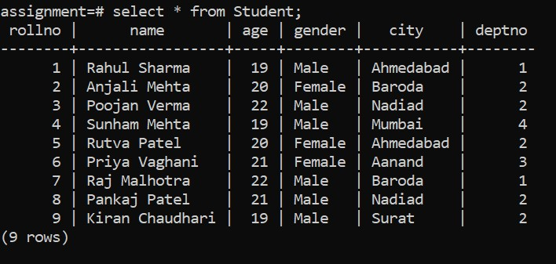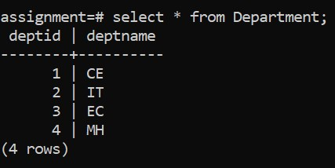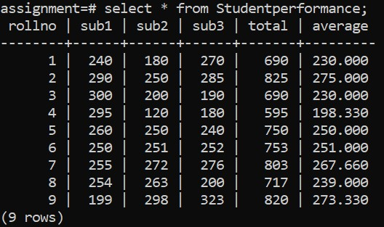

* **Queries :**-

1. 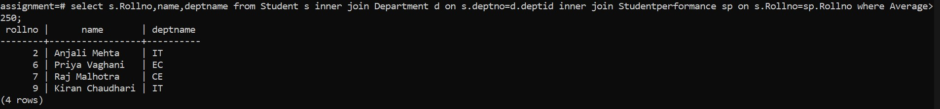Apply postgresql query to find student roll number, student name with department name for each student whose average marks is more than 250.
2. 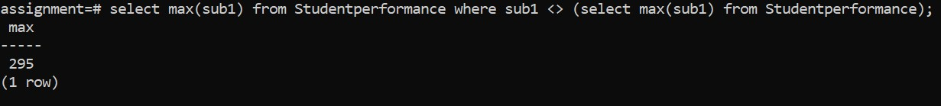Apply postgresql subquery to display the second highest marks in subject 1.
3. ****Apply postgresql subquery to find the department name of those departments who have more than 4 students studying in that department.
4. ****Apply postgresql query to display the name of students who got equal marks in subject 2.

Q3 – II

* **Tables :-**

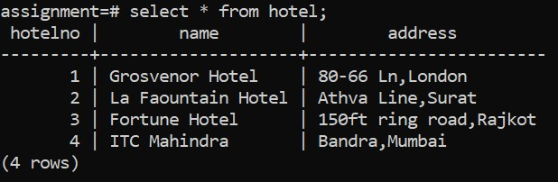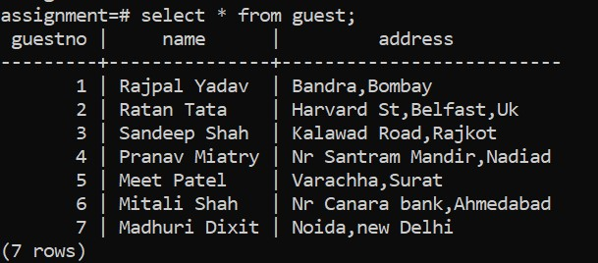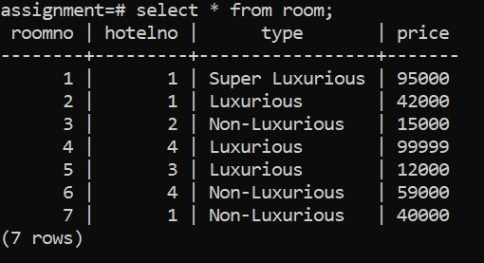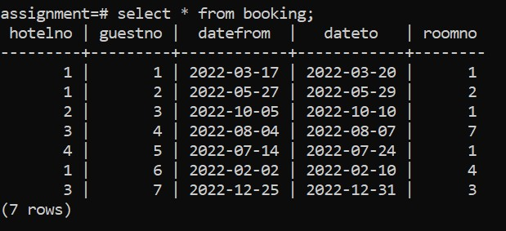

* **Queries :-**

1. 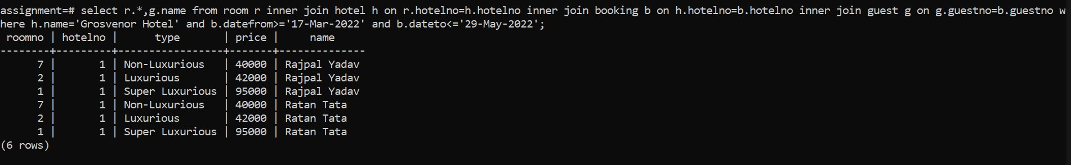Apply postgresql subquery to list the details of all rooms at the ‘Grosvenor Hotel’, including the name of the guest staying in the room, if the room is currently occupied.
2. 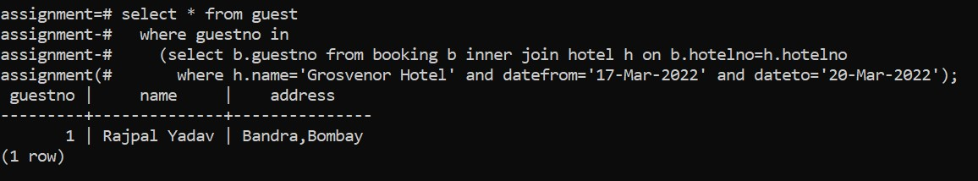Apply postgresql subquery to list all guests currently staying at the ‘Grosvenor Hotel’.
3. 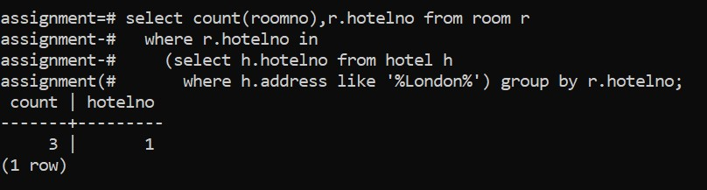Apply postgresql subquery to list the number of rooms in each hotel in ‘London’.
4. 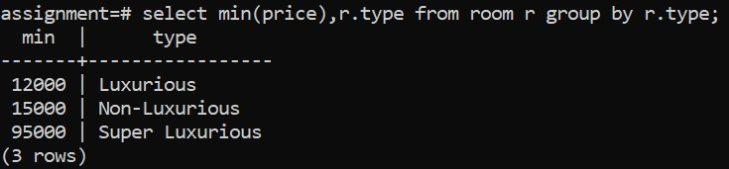Apply postgresql qury to find minimum price of a room according to room type.